**Project 11: Working with SNS, SQS, SES, and TRIGGERING CLOUDWATCH EVENT SNS NOTIFICATION**

**Task 1: Working with SNS**

1. SNS Console

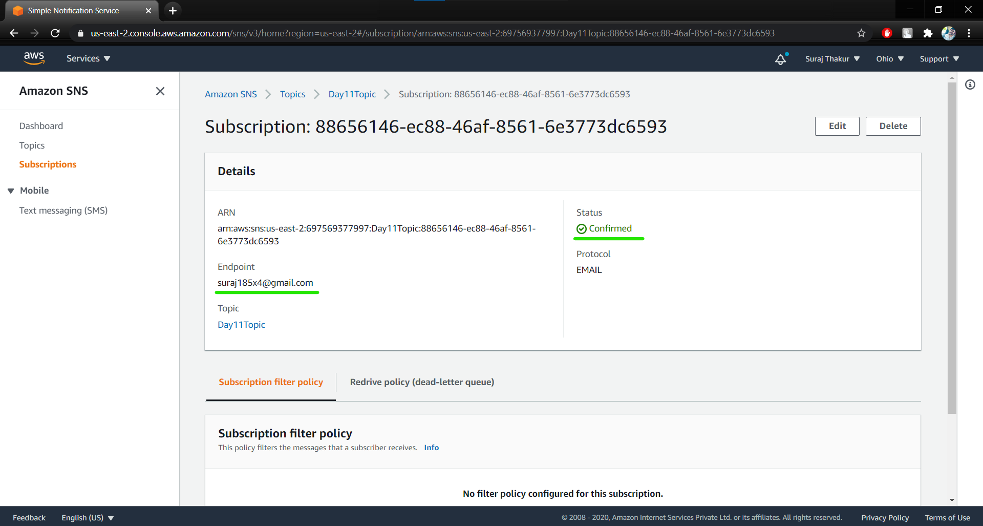

1. Inbox with the published message

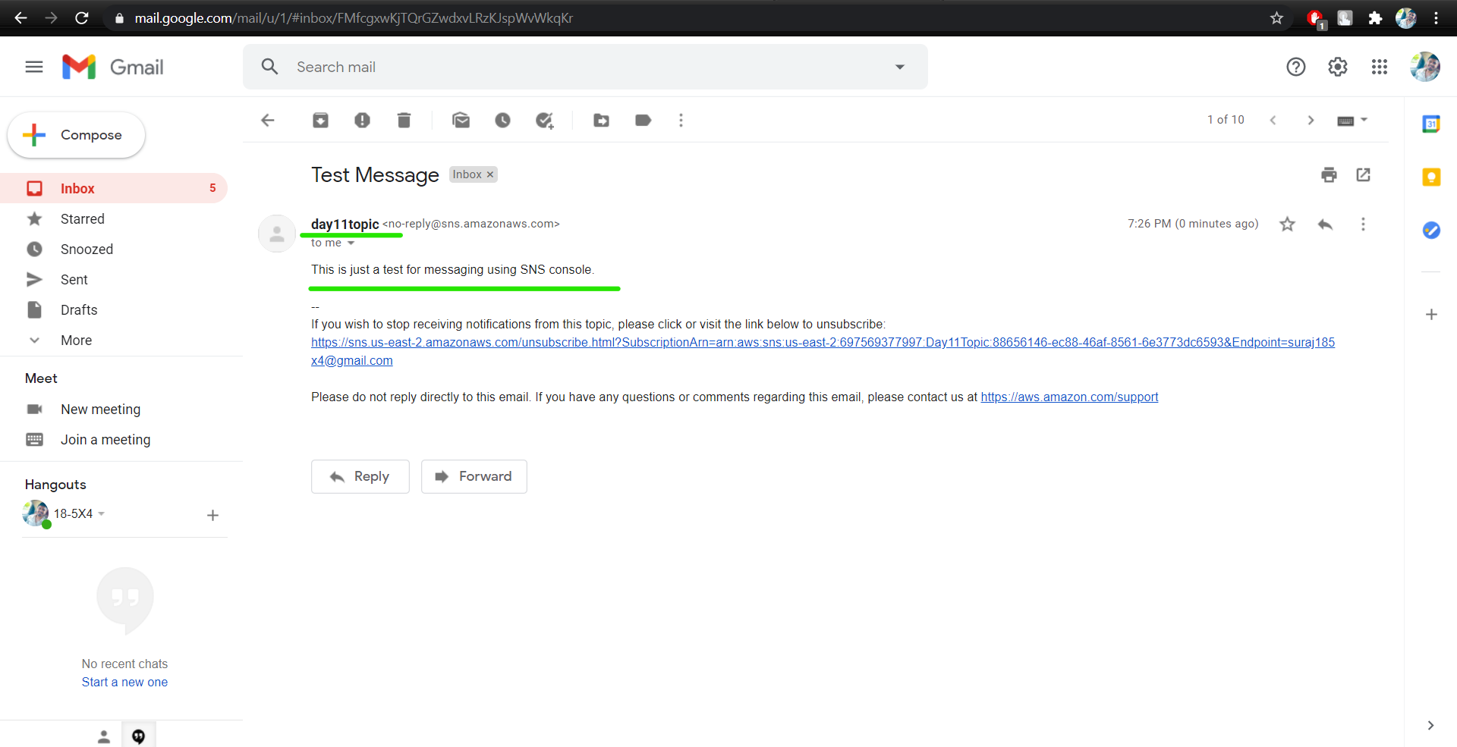

**Task 2: Working with SQS**

1. SQS console

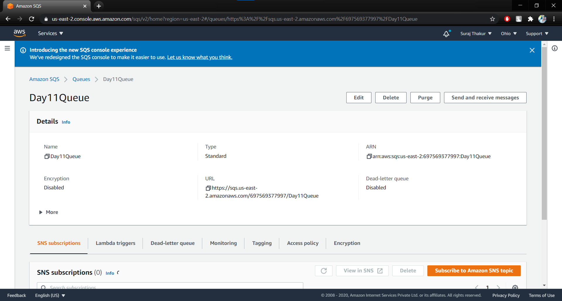

1. poll for messages and display message window

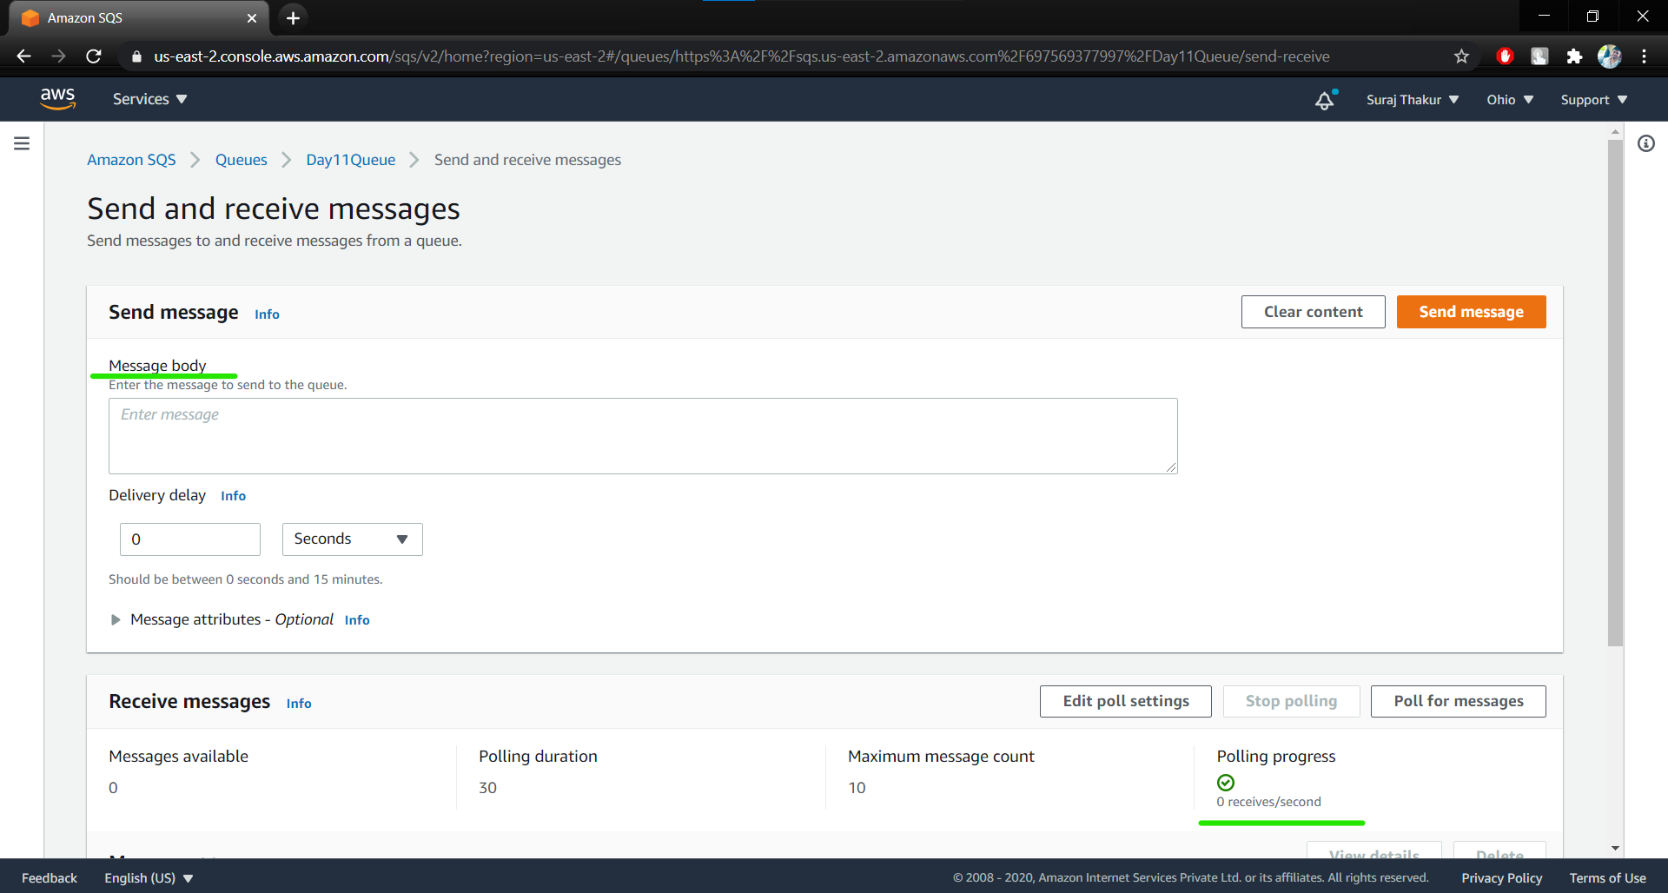

**Task 3: Working with SES**

1. Inbox mail verification

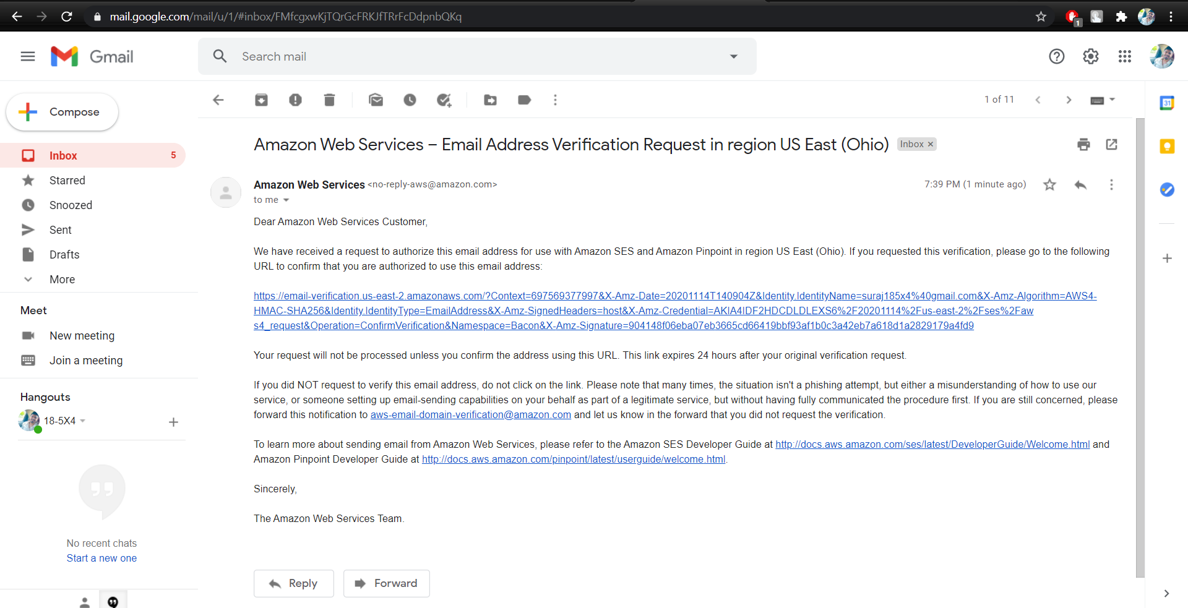

**Task 4: TRIGGERING CLOUDWATCH EVENT SNS NOTIFICATION**

1. EC2 console

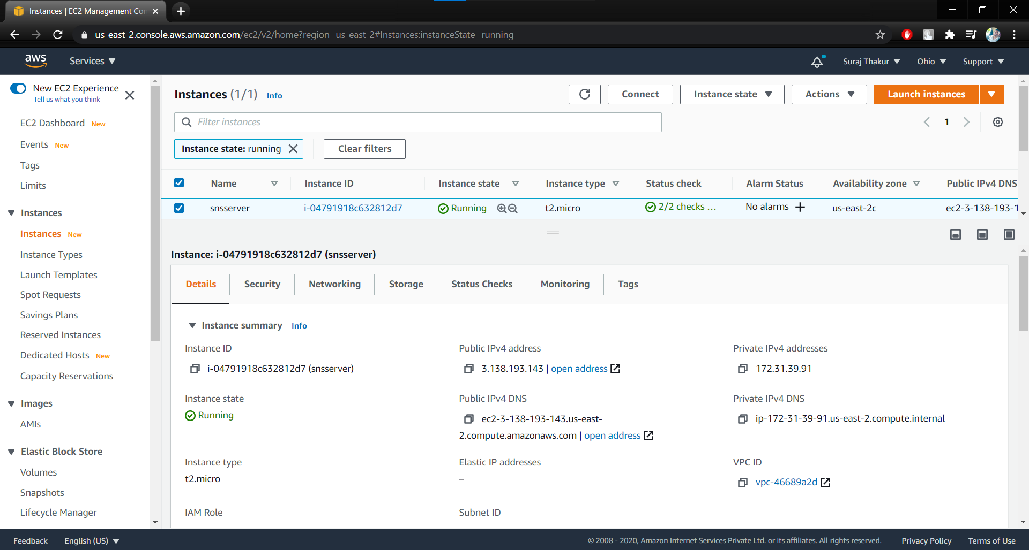

1. Rule configuration

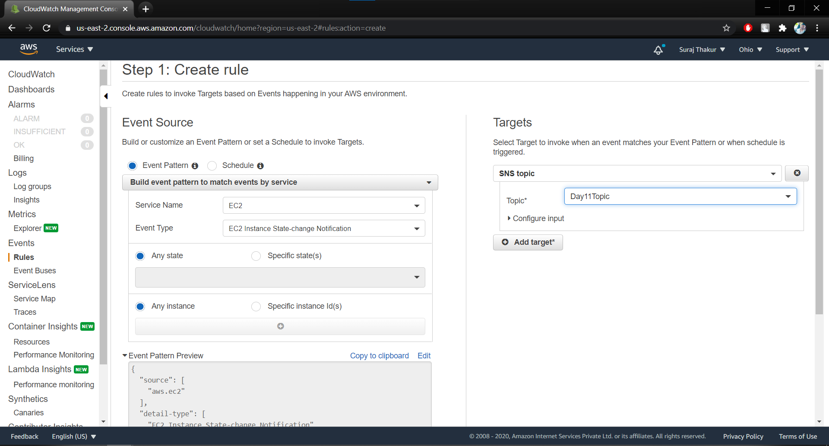

1. SNS topic

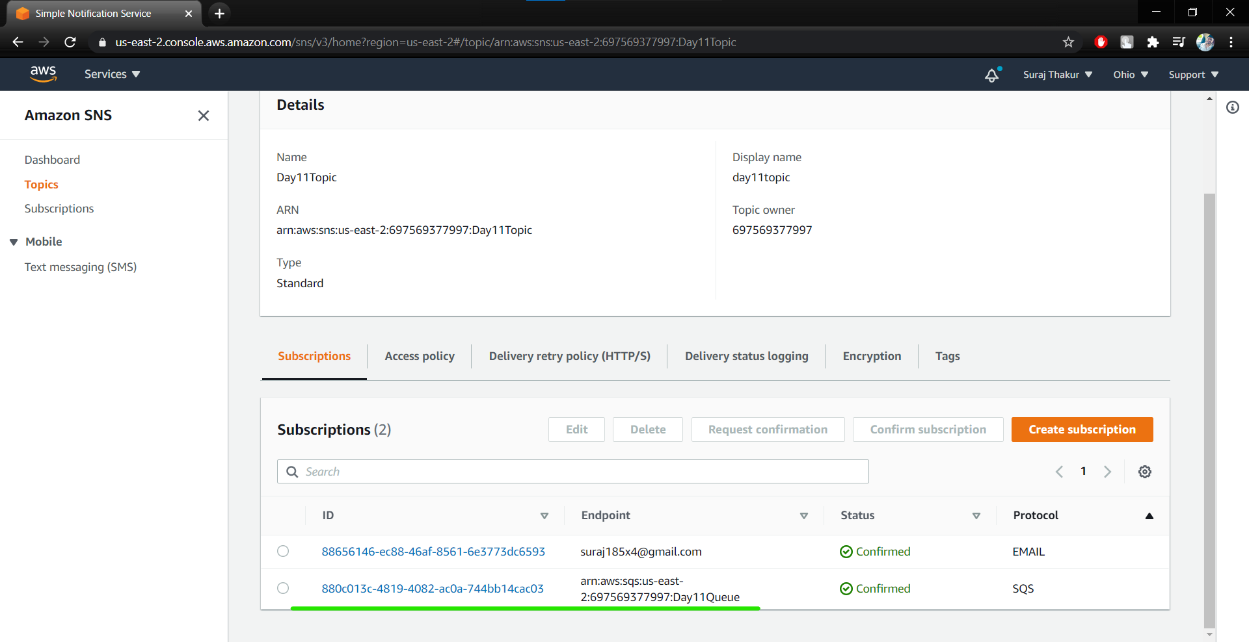

1. state change event notification in your mailbox

